1. To create an application folder, first navigate to the team folder.
2. Once you are in the team folder, click **New Item**.

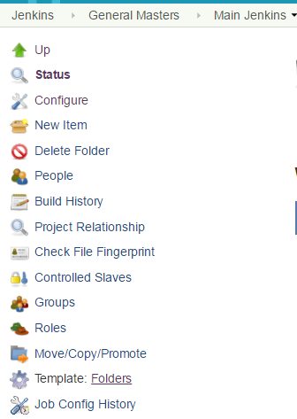

1. When you select New Item, you’ll be taken to a new window like below. Here you need to Enter a name for the item (Folder) you are creating and select **Folders** option. Click **OK** when you are done.

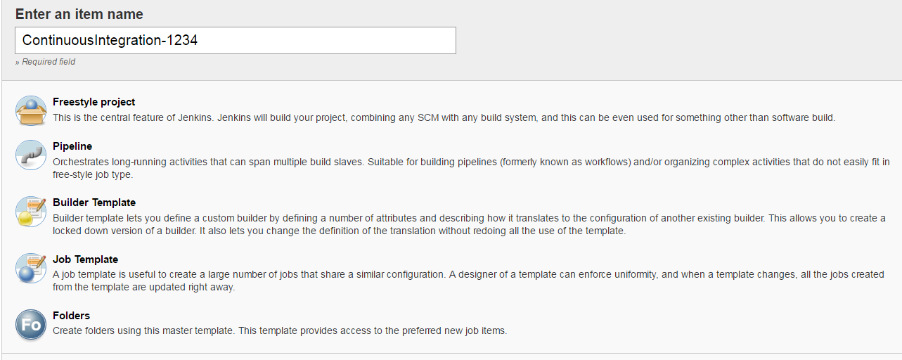

1. Now, click Apply and then Save buttons.

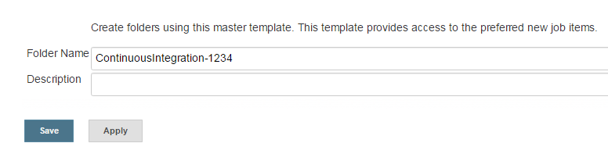

1. When you are done creating the application folder, navigate back to the team folder and select **Groups** option from the menu

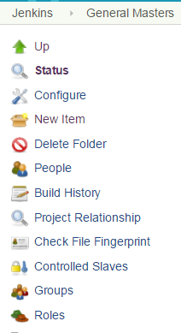

1. When you select Groups, you will get below two options. Select **New Group**

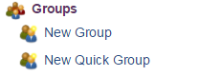

1. You need to provide a name to the group, give the name as **Leads** and click ok.

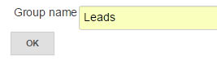

1. Now you need to select roles for the Leads group. Make sure you **checked** the **lead** option only under Roles and click **Save**.

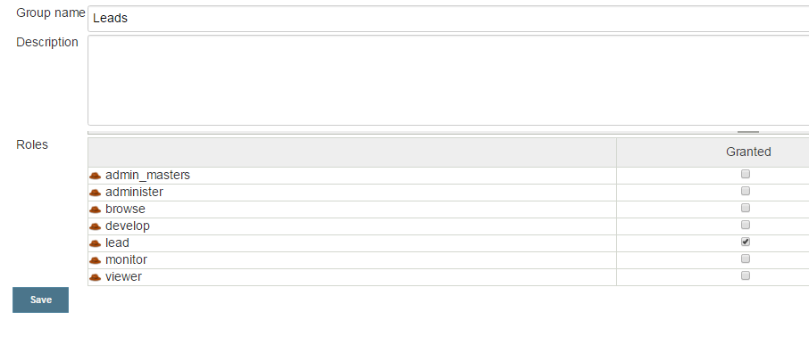

9) Once you are done assigning role to the Leads group, you need to add **Active Directory** (AD) groups to the Leads group that we just created. Click**Add user/group**.

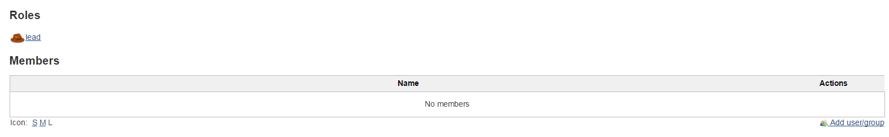

10) Now provide the group in the following syntax [svn_application_APPID_readwrite](https://jenkins.prod.cloud.fedex.com:8443/jenkins/externalGroups/svn_application_6143_readwrite). Make sure you replace the word APPID with actual application ID and click **OK**.



11) Now, you need to create **another group** under the application folder with name **Developers.**

12)Repeat the steps from 5 through 10 but, with couple of modificationsthat are provided below

1. Check the **develop** option under Roles

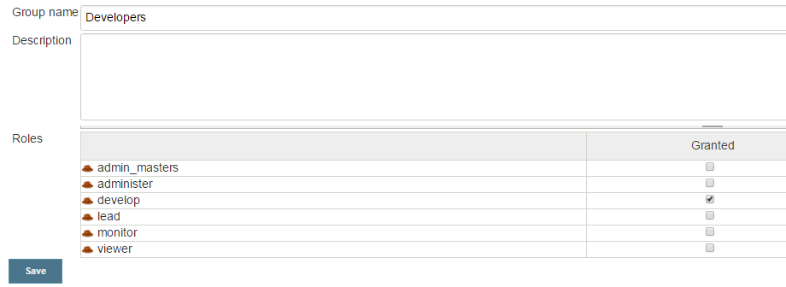

1. Add the following AD group to the Developers group [svn_application_APPID_readonly](https://jenkins.prod.cloud.fedex.com:8443/jenkins/externalGroups/svn_application_4112_readonly). Make sure the group you are adding for developers is **readonly** not **readwrite.**



13) Finally, click **Groups** option at the application folder level, you should see something like below.

